# Art Studio App:

## Main Features Brainstorm:

1. Palette Generator

* Randomly generate 6 color swatches in shapes
  + Lock and Delete option (Coolors inspo)
* Show hex code
* Button to generate new palette
* Button to save palette as image

1. Art Prompt Generator

* Random Subject(option for 1 or more)/Style (Art period/Artists)/Mood
* Button to Generate Prompt
* Possible LLM API?

1. Random Image Picker

* Local because API expensive
* Display 1-3 images (give options)
* Button displays new image(s)
* Save images option

1. Study Mode
   * Generate randomly from at least 2 of the above
   * Timer
     1. Single timer mode (30sec, 1min, 5min, 15min, 30min)
     2. Progression mode (pause in between)
     3. Toggle page lock mode
2. Save Reference
   * For saved palette, prompts, and images

## Palette Generator Algorithm

### <https://www.jacobwsmith.xyz/stories/color_schemes.html>

### Color Theory (Methods)

| **Color Scheme** | **How the Hue Shifts** |
| --- | --- |
| Analogous | ± 30° from base |
| Complementary | +180° from base |
| Triadic | +120°, +240° from base |
| Split-Complementary | +150°, +210° from base |
| Tetradic | Two complements, 90° apart |
| Monochromatic | Shifts saturation and value of one color |

Thus, HSL/HSV is the better option as it can wrap around 360°.

Still random, but narrower options (“Advanced Options” for user)

Tone Selection

1. Vibrant
2. Pastel
3. Muted
4. Dark

Hue Selection

1. Warm colors only
2. Cool colors only
3. No Filter

| **User Selection (Tone + Hue Bias)** | **Possible Palette mood** | **Math** |
| --- | --- | --- |
| Vibrant | Random Vibrant | Saturation: 80–100% Brightness: 60–100% Any hue |
| Pastel | Random Pastel | Saturation: 20–50% Brightness: 80–100% Any hue |
| Muted | Random Muted | Saturation: 20–50% Brightness: 40–70% Any hue |
| Dark | Random Dark | Saturation: 40–70% Brightness: 10–40% Any hue |
| Vibrant + Warm | Heat Map | Hue: Red–Yellow (~0–60°) Saturation: 80–100% Brightness: 60–100% |
| Vibrant + Cool | Neon Cool | Hue: Cyan–Violet (~180–300°) Saturation: 90–100% Brightness: 70–100% |
| Pastel + Warm | Cozy Sunny Day | Hue: Red–Yellow (~0–60°) Saturation: 20–40% Brightness: 80–100% |
| Pastel + Cool | Cozy Evening | Hue: Cyan–Violet (~180–300°) Saturation: 20–40% Brightness: 80–100% |
| Muted + Warm | Earthy | Hue: Red–Yellow (~0–60°) Saturation: 20–50% Brightness: 40–70% |
| Muted + Cool | Dusty Cool | Hue: Cyan–Violet (~180–300°) Saturation: 20–50% Brightness: 40–70% |
| Dark + Warm | Deep Warm | Hue: Red–Yellow (~0–60°) Saturation: 40–70% Brightness: 10–40% |
| Dark + Cool | Deep Cool | Hue: Cyan–Violet (~180–300°) Saturation: 40–70% Brightness: 10–40% |
| Dark + Vibrant | Jewel Tones | Saturation: 80–100% Brightness: 20–50% Hue: Full range (~0–360°) but richer colors |
| Dark + Muted | Stormy | Saturation: 20–50% Brightness: 10–40% Hue: Full range |

For more than 5 colors: mix theories and apply HSL applications. But prob limit to just 5.

## Prompt Generation

Option 1: .JSON of words and just randomly generated in three separate categories -> straightforward application

Option 2: TinyLlama(or GPT2.0) for generation (lightweight llm) -> challenging application

1. Train TinyLlama
   * Use pretrain model
   * Finetune
2. REST API Backend
   * FastAPI server (?)
3. .NET MAUI Integration
   * HTTP client
   * Connect to FastAPI

* Word prompt:
  + Objects: <toggle 1-5 nouns> Generate random objects
  + Style: Generate random style (e.g Arcane (Netflix), Ghibli, Brutalism)
  + Setting/Mood: Generate random mood, physical settings, etc

Most likely going with option 1 due to time constraints.

## Random Picture Generator

Option 1: Local

Option 2: Unsplash API -> JS wrap limit to 50 request per day/hour whichever comes first.

## Study Mode

Standard Interval vs Session Intervals. Randomly generate references to practice concept art from imagination

## Saved References

Allows users to refer back to old references (palette, word prompts, images)

## Main Page

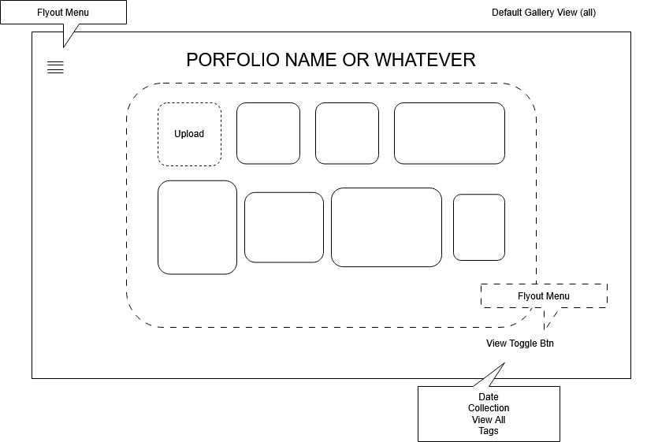

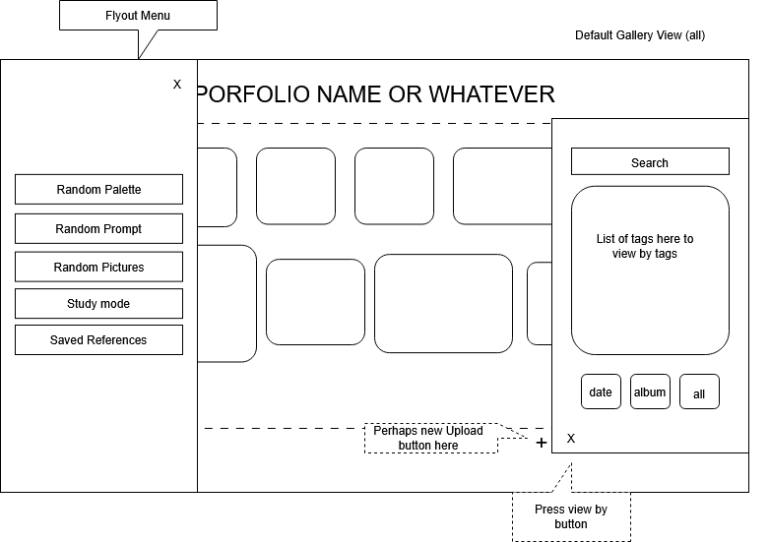

## Palette Generator Page

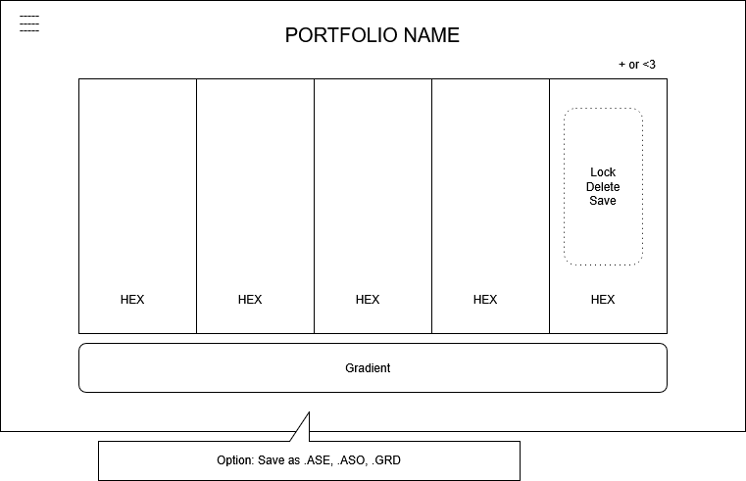

For file save options: jpg/png/.ASE/.ASO prob another drop down menu somewhere. Perhaps hover over the heart or something

Another Option: save palette to collection

Need to differentiate header from body

## Word Prompt Page

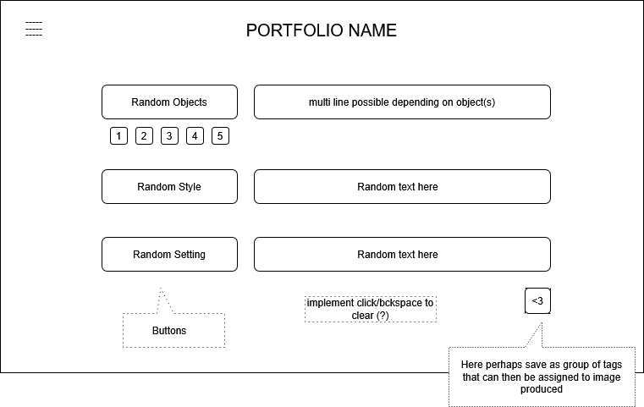

Need to differentiate header from body

Random Prompt Generator

## Picture Prompt Page

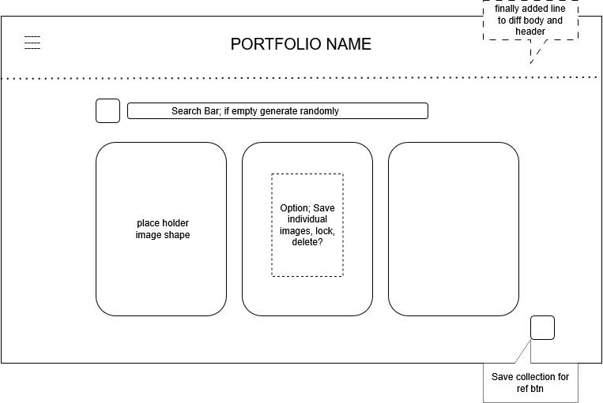

Random image generator from Unsplash API or local

## Study Mode

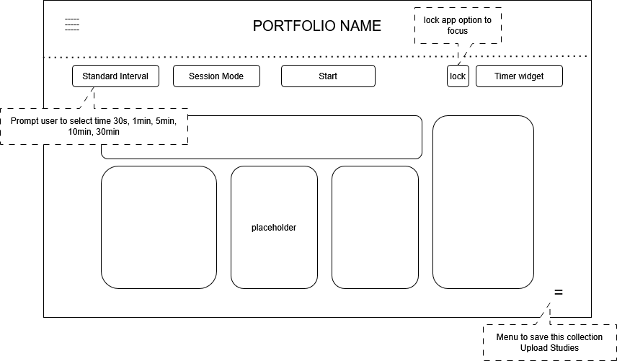

Study Mode -> perhaps have option for continuous? After 30 sec, generate a new set of references. Right now, set to stop after each time.

Lock app -> cannot regenerate until session is over probably set opacity over it unless Session Mode selected

## Saved Reference Page

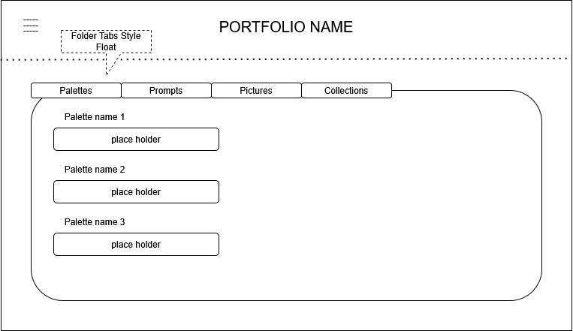

MAUI TabbedPage layout

Should have + at each end of “placeholder shape” for drop down menu option like assigned palette tag/prompts/picture to image and an un-heart method.

## Process

1. Wire frame -> ugly for now
2. Get ONE working page
3. Call it a day until next time.

References:

<https://fonts.google.com/icons>

<https://learn.microsoft.com/en-us/dotnet/api/microsoft.maui.controls.flyoutitem?view=net-maui-9.0>

<https://learn.microsoft.com/en-us/dotnet/maui/user-interface/pages/tabbedpage?view=net-maui-9.0>

<https://enisn-projects.io/docs/en/uranium/latest/infrastructure/Dropdown>

<https://stackoverflow.com/questions/78731403/maui-dropdown-select>

<https://learn.microsoft.com/en-us/dotnet/maui/platform-integration/storage/file-picker?view=net-maui-9.0&tabs=windows>

<https://github.com/unsplash/unsplash-js>

lord and savior: <https://www.youtube.com/@JamesMontemagno>